Monitor de vía

Test suite
Amount to pay message on DLG_InicioCobroActual

 | Author | Date
Creation | Dvera | 30/09/2026
Last Revision | Dvera | 30/09/2026

DOCUMENT REVISIONS

Revision | Date | Author | Pages | Modifications
1 | 30/09/2026 | DVERA | All | Initial version.

Content
1 Description 4
1.1 Test environment 4
1.2 Element under test 4
1.3 Test summary 5
2 Opening the element in the web configurator 6
2.1 Element editor 7
3 TC-01. Amount to pay enabled 9
4 TC-02. Amount to pay disabled 13
5 TC-03. Amount to pay enabled again 16
6 Conclusion 20
7 Annex. Code of the Amount to pay row 21

Description
This test suite checks that the Amount to pay message of the DLG_InicioCobroActual screen (dispatch code 89) can be enabled and disabled from the web configurator of Monitor de vía, and that the Monitor de vía application shows the change on the display.
The change is made on the Edit current config tab of the web configurator, and the result is checked by sending the screen to the display from the Testing tab.
Note: The screenshots of the application were taken on a test Android device connected to the same network. On the 55'' display the screens are the same, scaled to the display size.

Test environment
Item | Value
Application | Monitor de vía 2.1.9
Device | Test Android device (Android 9) with IP address 192.168.101.100, WiFi switched on and connected to the same network as the computer.
Web configurator | Google Chrome on a Windows computer: http://192.168.101.100:8080
Configuration panel password | Parking2010
Connection way | Testing (Connection tab). The screens sent from the Testing tab are only shown on the display with this connection way.
Screen under test | DLG_InicioCobroActual (dispatch code 89)
DIT used | Amount To Pay (type 3): fields AmountTotal and AmountAlreadyPayed, in cents.
Test date | 29/09/2026

Element under test
The DLG_InicioCobroActual screen shows an orange column with the text PROCESSING PAYMENT and, below it, a row with the Amount to pay: text and the amount. The amount is the text with the ID amount-to-pay-value, linked to the AmountTotal data key of the DIT type 3.
The message is enabled when this row is part of the column, and disabled when the row is removed. The Structure tree of the element editor shows the row and its content:
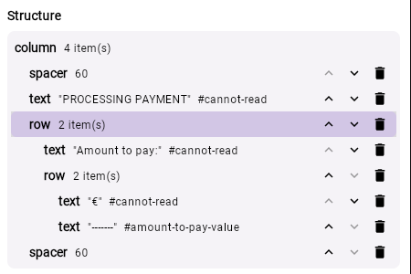
Figure 1. Structure of the orange column. The selected row contains the "Amount to pay:" text and the amount (amount-to-pay-value).

Test summary
ID | Test | Expected result | Result
TC-01 | Amount to pay enabled | The display shows PROCESSING PAYMENT and "Amount to pay: € 12.50" for AmountTotal = 1250. | PASSED
TC-02 | Amount to pay disabled from the Properties tab | The display shows only PROCESSING PAYMENT. The Testing tab does not request any DIT. | PASSED
TC-03 | Amount to pay enabled again from the JSON tab | The row is restored and the display shows "Amount to pay: € 8.75" for AmountTotal = 875. | PASSED

Opening the element in the web configurator
Note: Before the tests, select the connection way Testing in the Connection tab and press SAVE, otherwise the display does not show the screens sent from the Testing tab. When the tests are finished, set the connection way back to SignalR or Socket and press SAVE.
The three tests start from the same steps:
- Open Google Chrome on the computer and go to http://<display IP>:8080 (in this test, http://192.168.101.100:8080).
- On the initial screen, select Go to dashboard setting panel and enter the password Parking2010.
- Select the Edit current config tab in the side menu. The screens of the current configuration of the display are listed.
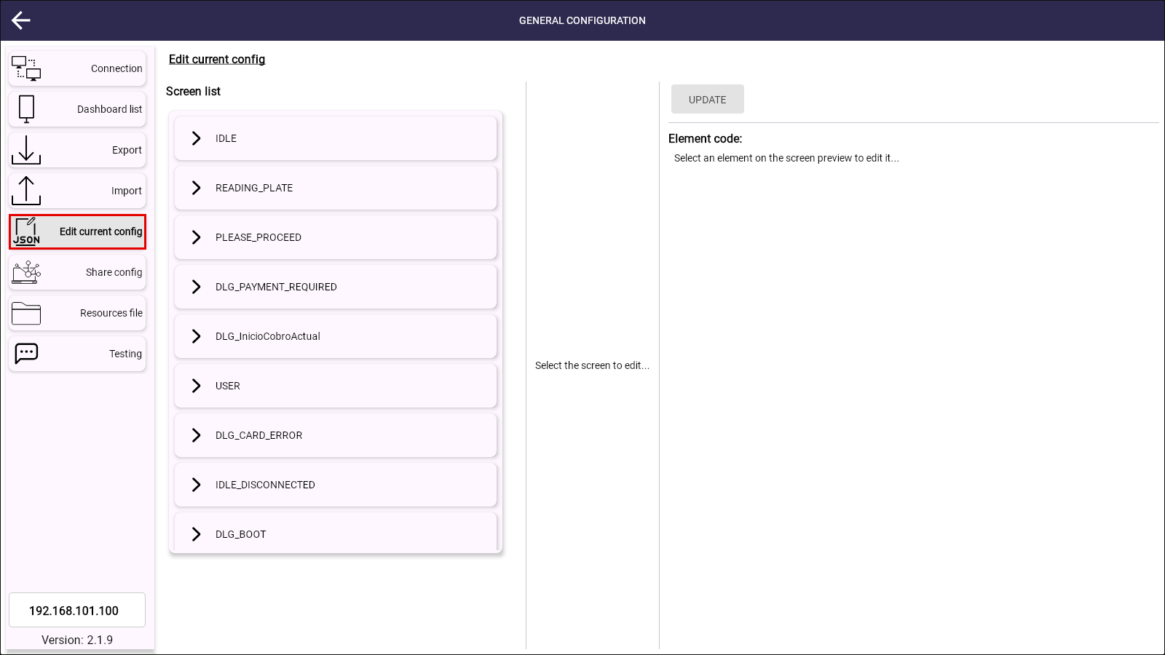
Figure 2. Edit current config tab with the screen list of the display.
- Select DLG_InicioCobroActual in the Screen list. The Screen preview shows the screen.
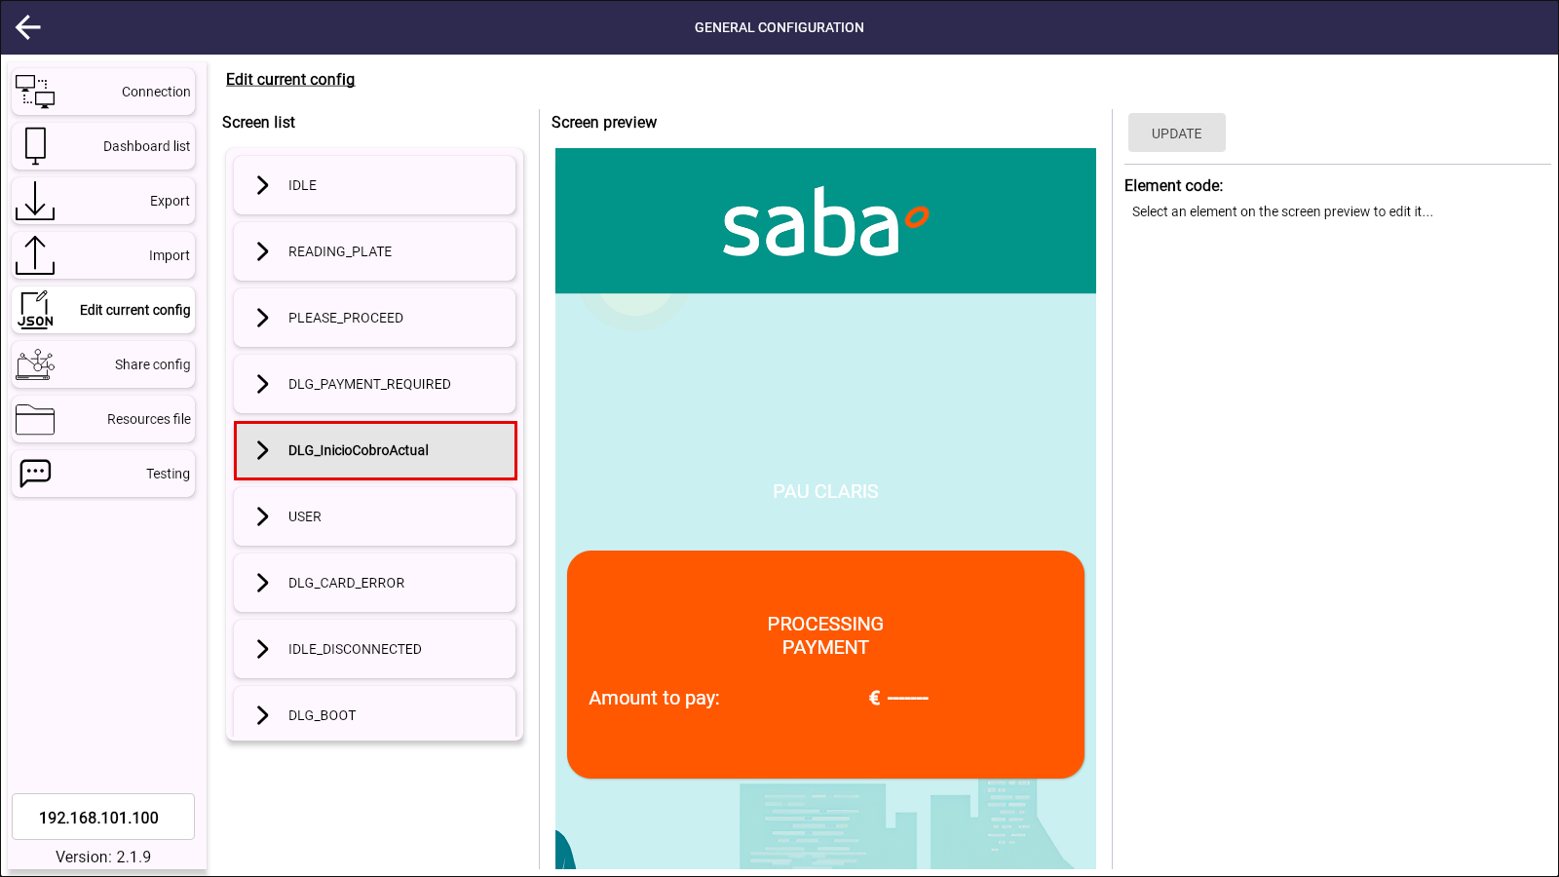
Figure 3. DLG_InicioCobroActual selected. The screen preview is loaded.
- Click the orange box of the screen preview. The box is highlighted and the element editor opens on the right, in the Properties tab.
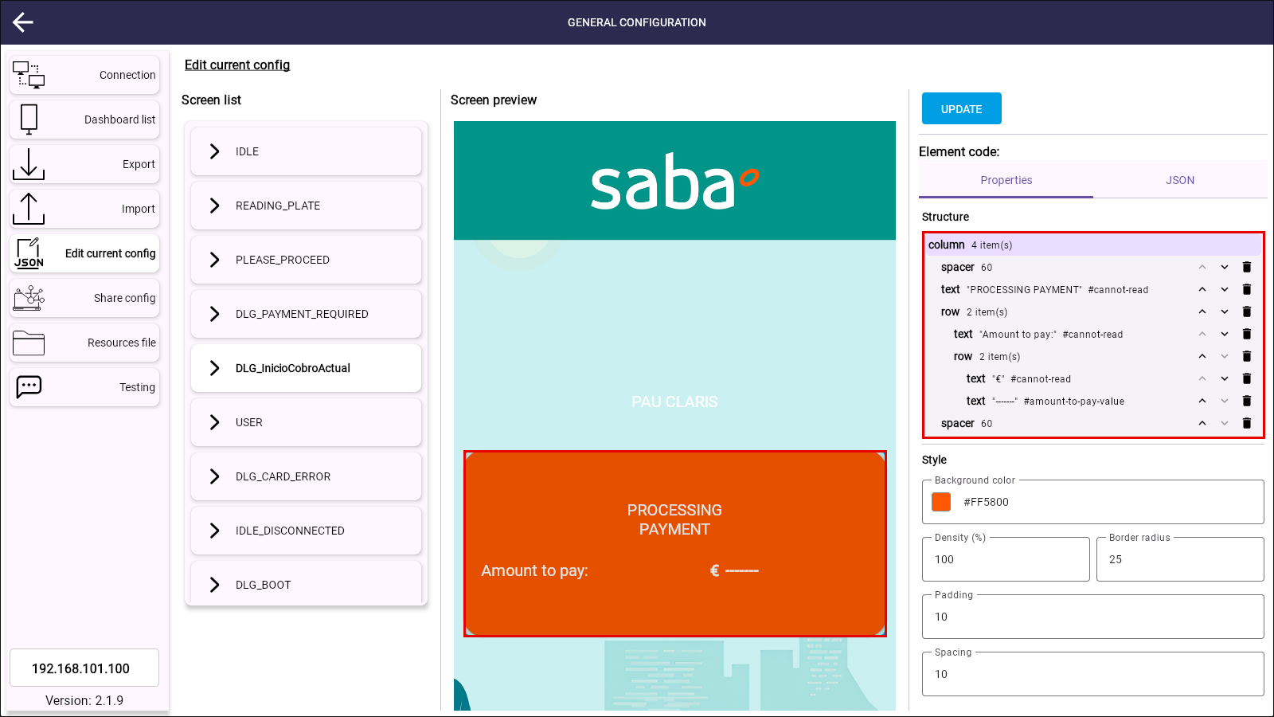
Figure 4. Orange box selected. The Properties tab shows its structure and fields.

Element editor
The element editor has two tabs:
- Properties: shows the Structure tree of the selected element. Clicking a node of the tree shows the fields of that element (style, content, translations and DIT binding, depending on the element type). The + icon of a box, column or row adds a new element at the end of it (box, column, row, text, image, spacer or video), the arrows move the element up or down inside its parent, and the bin icon removes it. APPLY CHANGES updates the screen preview.
- JSON: shows the code of the element. It can be edited or replaced, and APPLY CHANGES updates the screen preview.
The changes are only saved on the display when UPDATE is clicked and the confirmation message is accepted.
Note: The changes applied to the screen preview are kept while the Edit current config tab is open, and the next UPDATE saves all of them. Leaving the tab or reloading the page discards the changes that were not saved.

TC-01. Amount to pay enabled
Objective: check that the display shows the Amount to pay message and the amount received in the DIT when the row is part of the orange column.
Precondition: the orange column of DLG_InicioCobroActual contains the Amount to pay row (default configuration).
- Follow the steps of section 2 to open the orange box of DLG_InicioCobroActual.
- In the Structure tree, check that the row with the "Amount to pay:" text and the amount-to-pay-value text is present. Keep it.
- Click UPDATE.
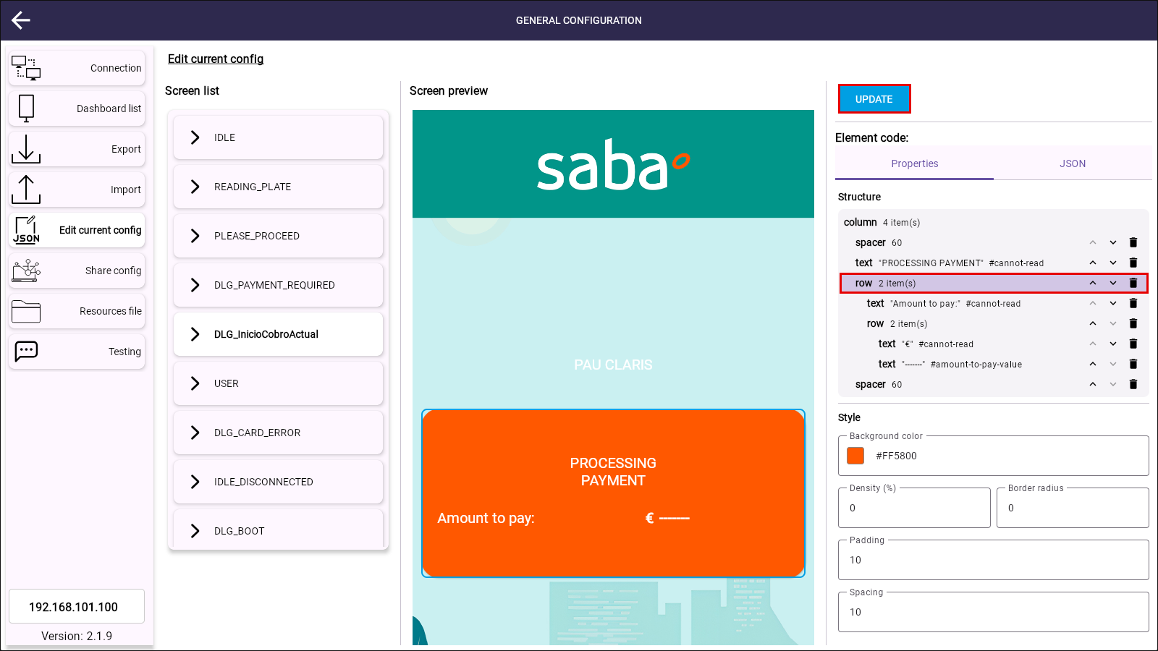
Figure 5. The Amount to pay row is present in the structure. UPDATE saves the element.
- Click ACCEPT in the confirmation message.
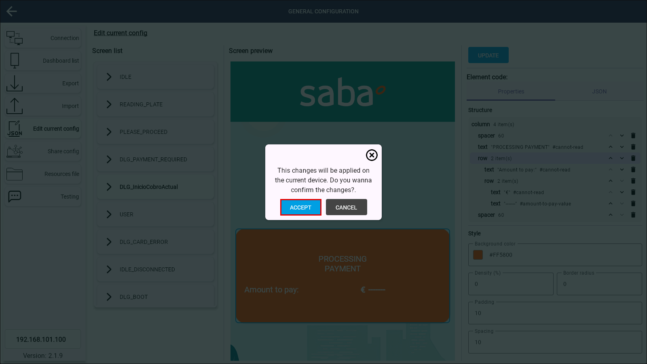
Figure 6. Confirmation message before saving the changes on the display.
The message "The new screens configuration has been saved successfully." is shown.
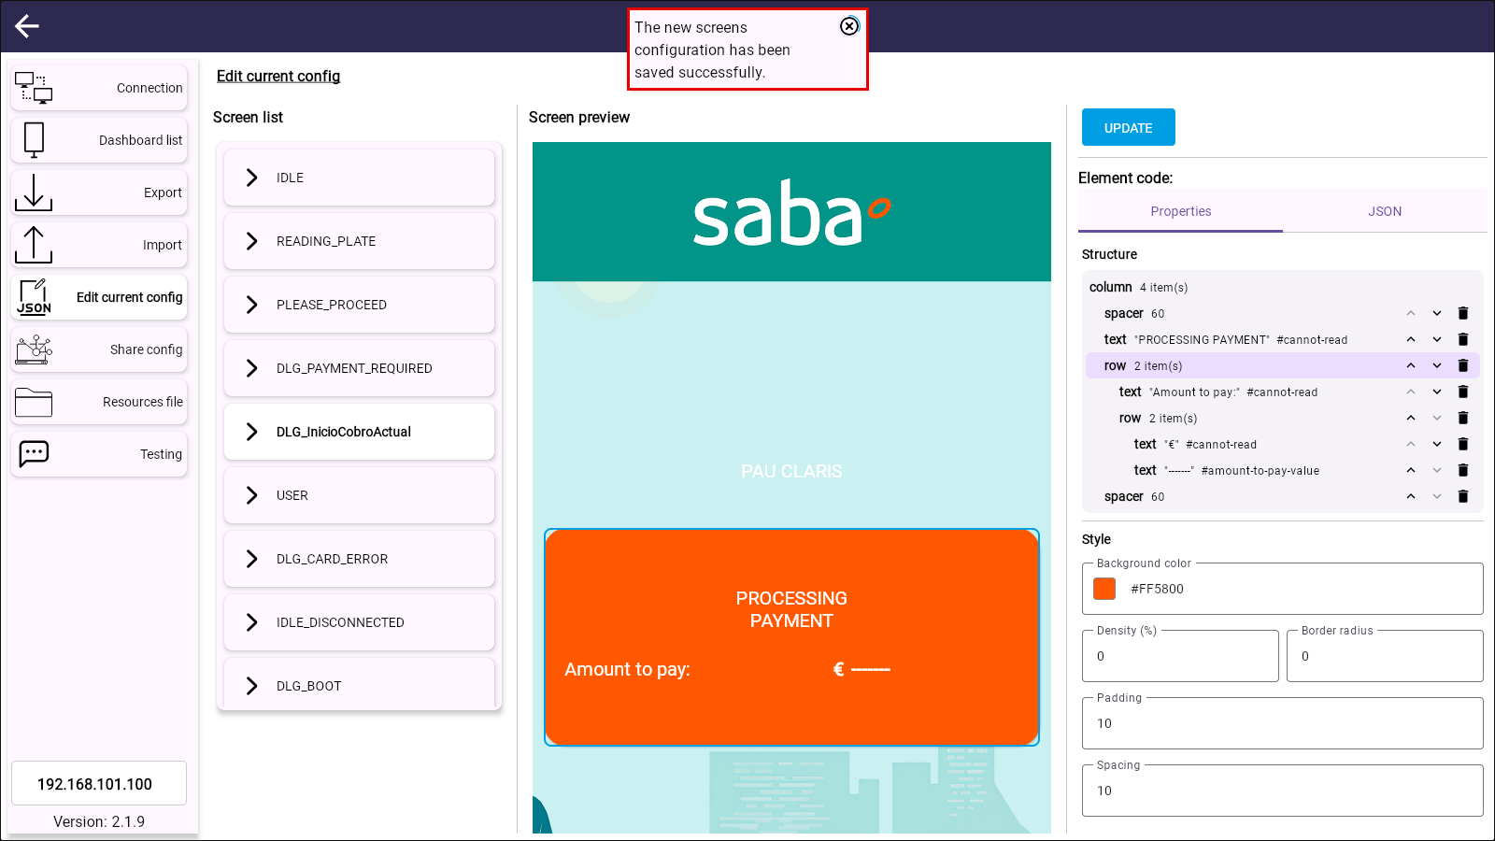
Figure 7. Configuration saved on the display.
- Select the Testing tab in the side menu and select DLG_InicioCobroActual in the screen list. The Amount To Pay (Type 3) DIT form is shown.
- Type 1250 in AmountTotal and 0 in AmountAlreadyPayed. The amounts are in cents, so 1250 is € 12.50.
- Click SEND.
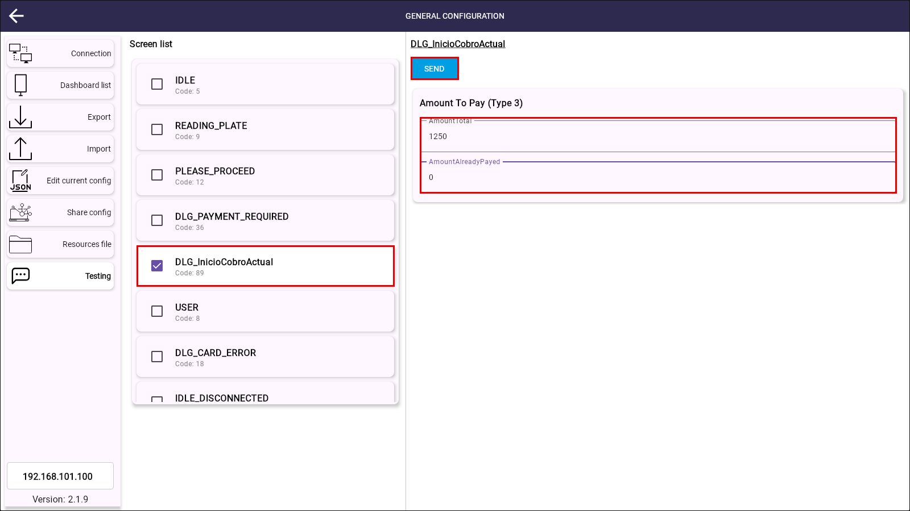
Figure 8. Testing tab with the DIT of the amount to pay.
The message "Dit config sent successfully" is shown and the display changes to the DLG_InicioCobroActual screen.
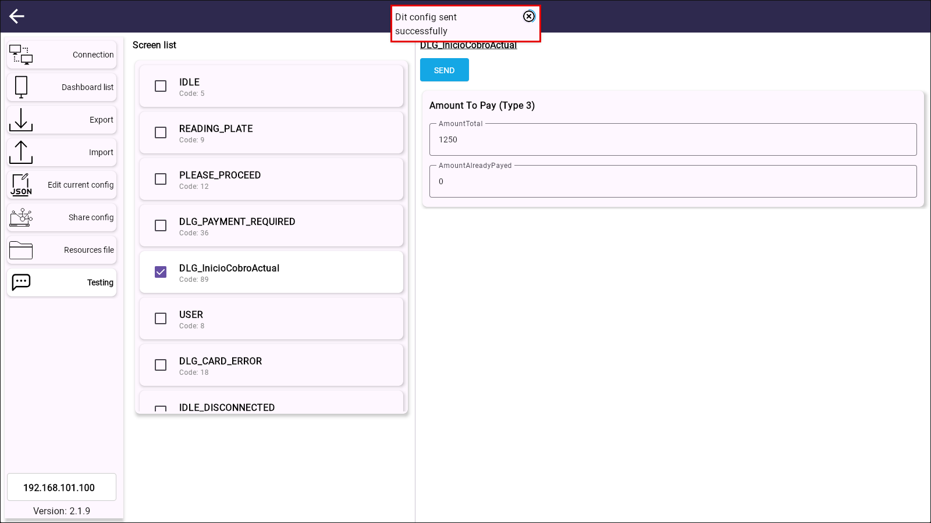
Figure 9. DIT sent to the display.
Expected result: the display shows PROCESSING PAYMENT and "Amount to pay: € 12.50".
Result: PASSED. The display shows the message with the amount received in the DIT.
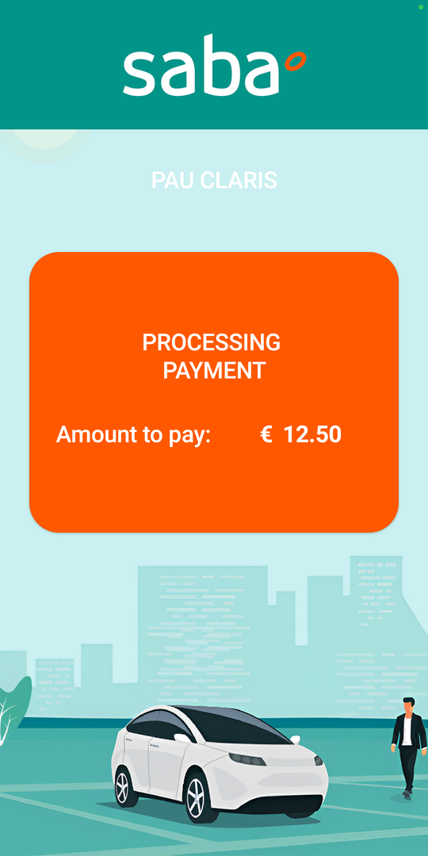
Figure 10. TC-01. The display shows the Amount to pay message.

TC-02. Amount to pay disabled
Objective: check that the Amount to pay message is not shown on the display when its row is removed from the orange column with the Properties tab.
Precondition: the orange column of DLG_InicioCobroActual contains the Amount to pay row.
- Follow the steps of section 2 to open the orange box of DLG_InicioCobroActual.
- In the Structure tree, click the bin icon of the row that contains the "Amount to pay:" text (the row with 2 items, directly under the PROCESSING PAYMENT text). The row and all its content are removed.
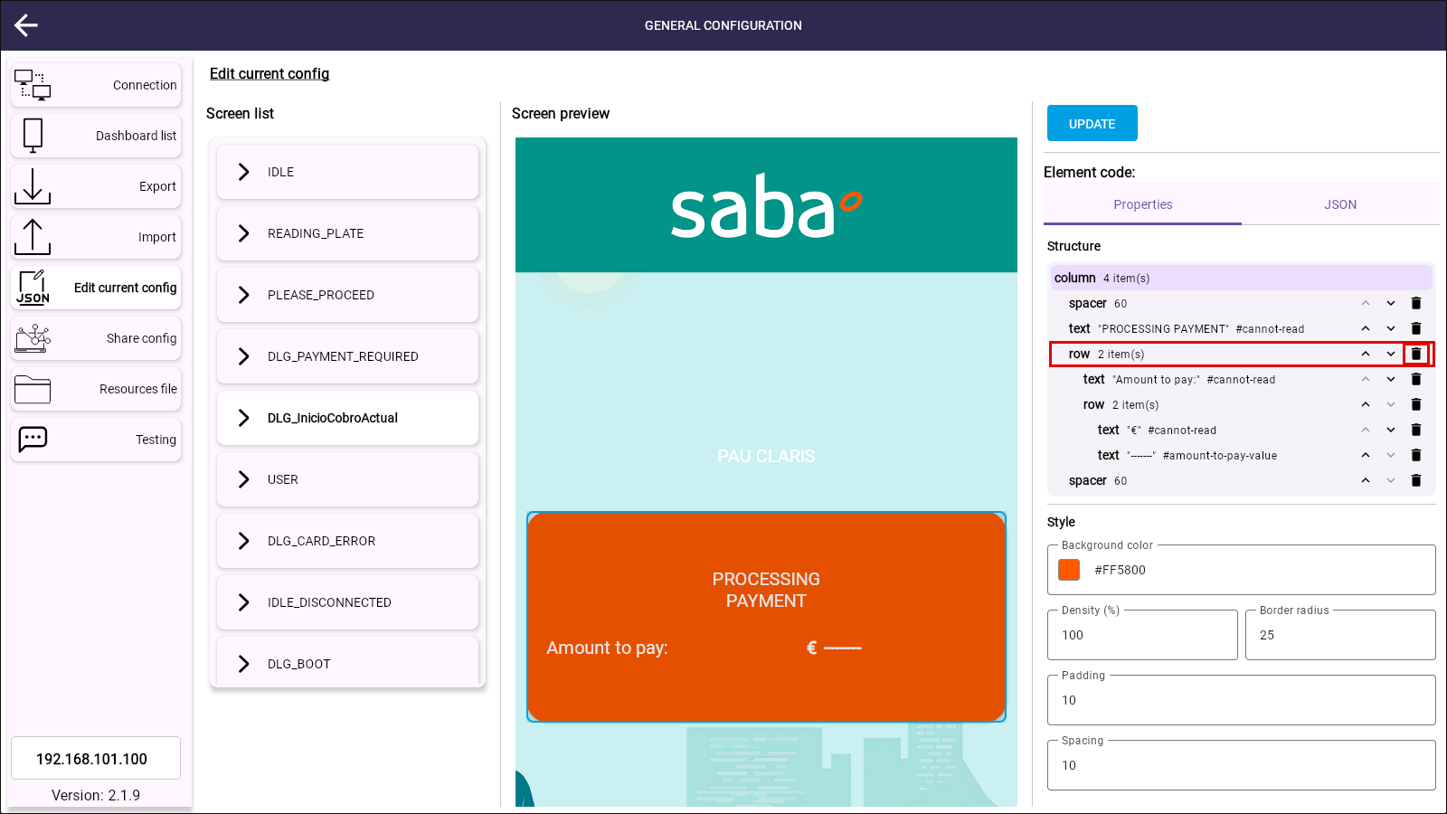
Figure 11. Bin icon of the Amount to pay row.
The structure keeps only the spacers and the PROCESSING PAYMENT text, and the screen preview no longer shows the Amount to pay message.
- Click UPDATE and then ACCEPT in the confirmation message.
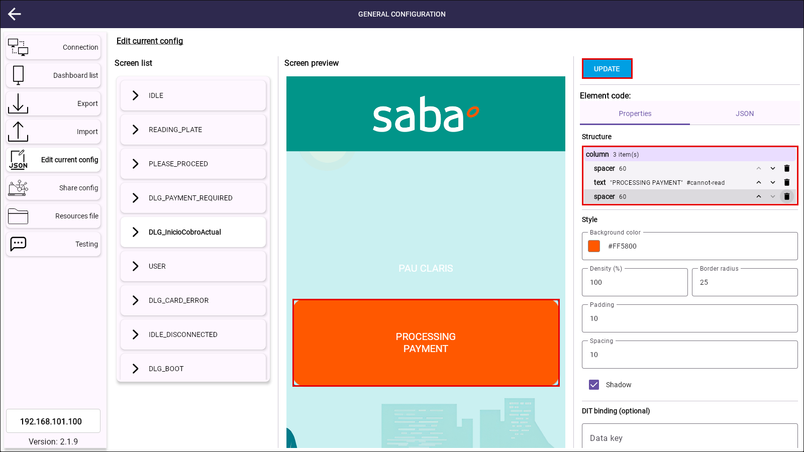
Figure 12. Row removed. The screen preview shows only PROCESSING PAYMENT.
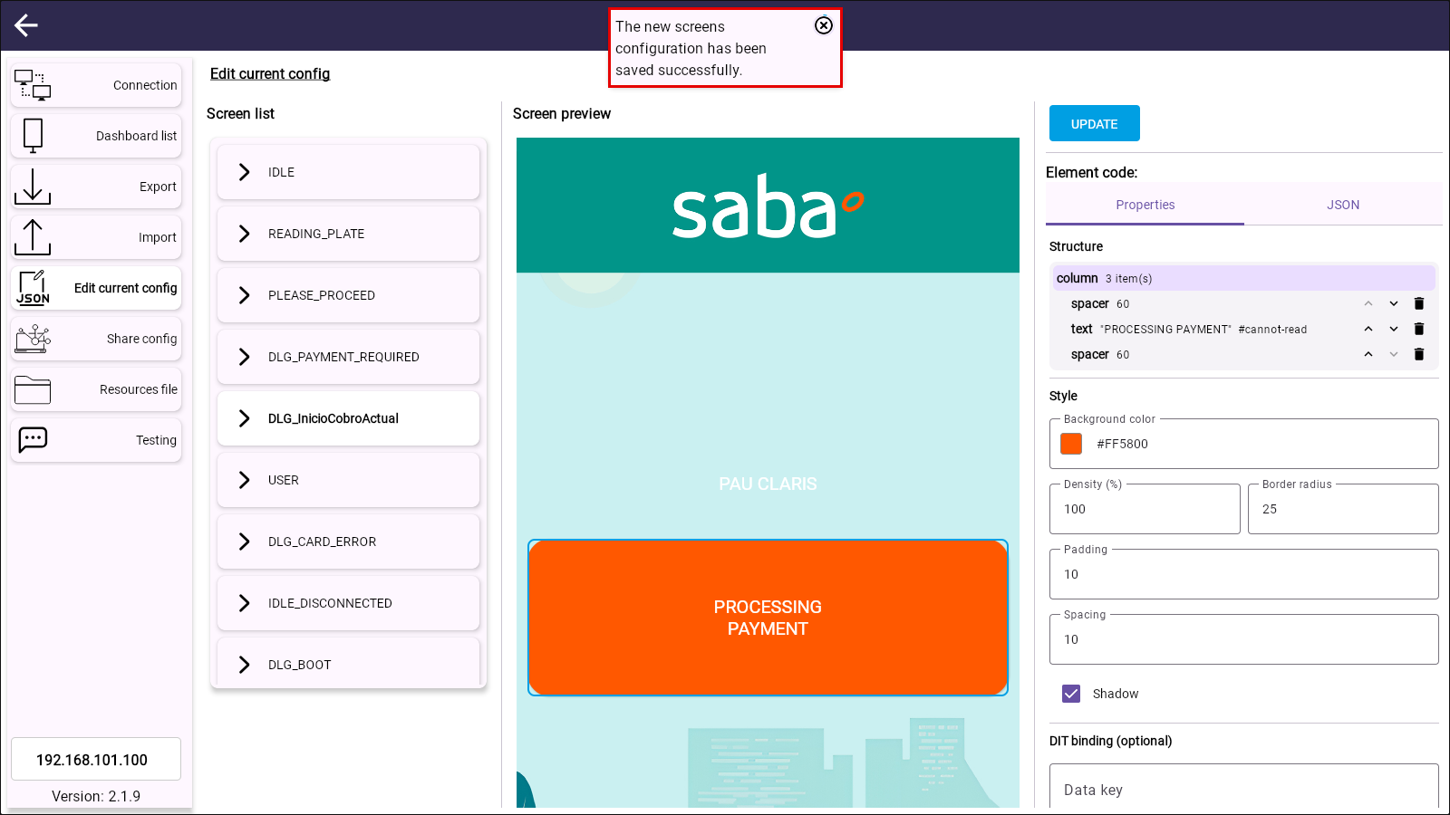
Figure 13. Configuration saved on the display without the Amount to pay row.
- Select the Testing tab and select DLG_InicioCobroActual. The screen no longer has elements linked to a DIT, so the message "There aren't items to show" is shown instead of the DIT form.
- Click SEND.
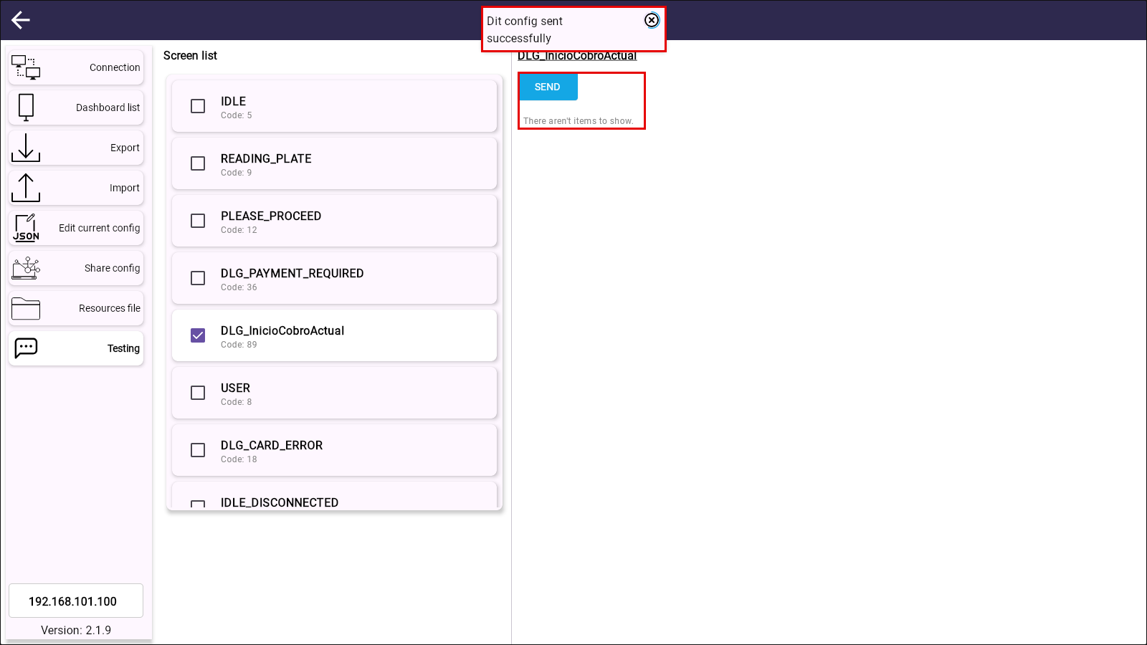
Figure 14. Testing tab without DIT fields. The screen is sent to the display.
Expected result: the display shows PROCESSING PAYMENT without the Amount to pay message.
Result: PASSED. The Amount to pay message is not shown.
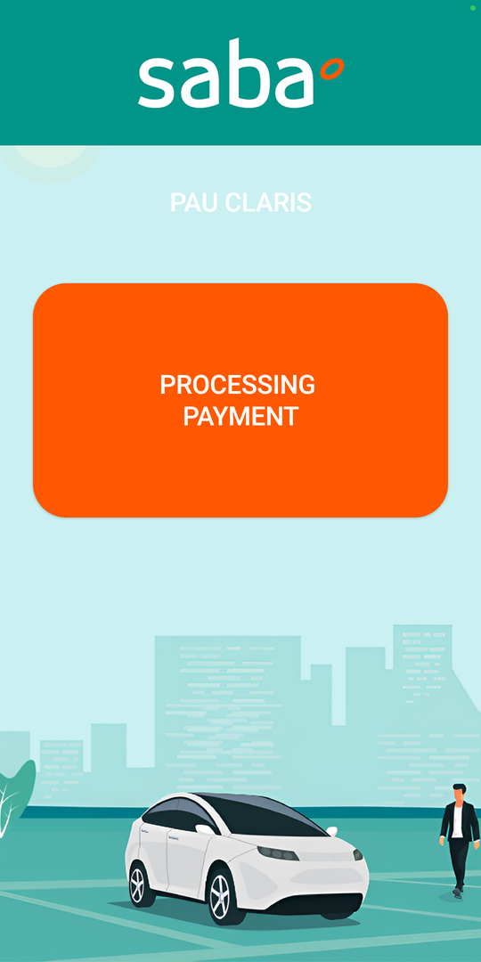
Figure 15. TC-02. The display shows the screen without the Amount to pay message.

TC-03. Amount to pay enabled again
Objective: check that the Amount to pay message can be enabled again from the JSON tab, after it has been removed.
Precondition: TC-02 has been run, so the orange column does not contain the Amount to pay row.
Note: The row could also be rebuilt with the + icon of the Structure tree, adding a row with its texts and filling in their fields. Pasting the code of the row in the JSON tab restores it exactly as it was, so this is the method used in this test. The code of the row is in section 7.
- Follow the steps of section 2 to open the orange box of DLG_InicioCobroActual.
- Select the JSON tab. The code of the orange column is shown, without the row.
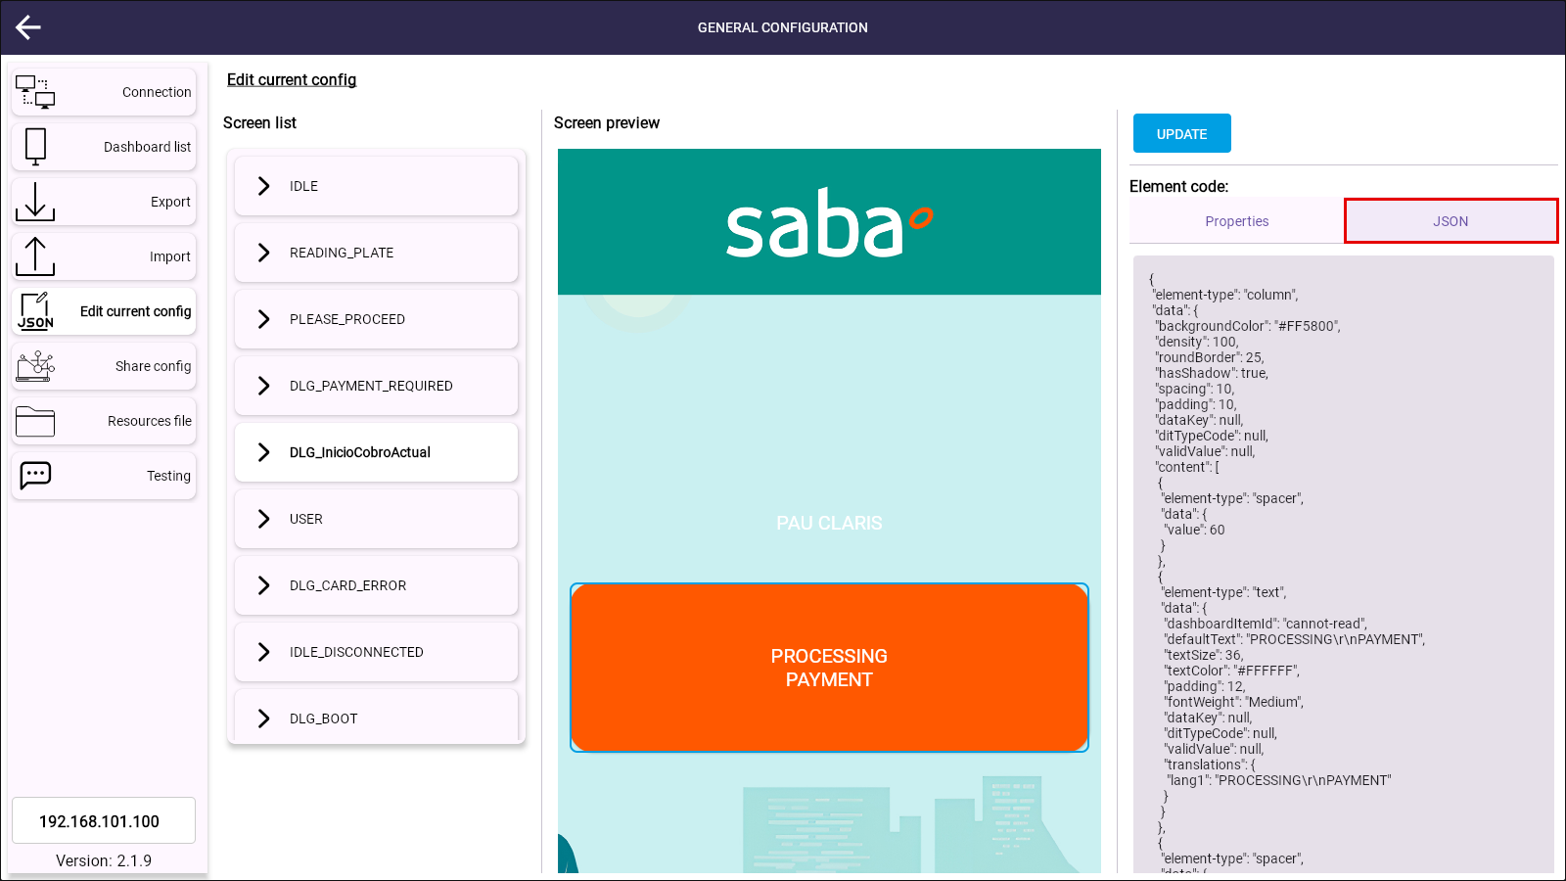
Figure 16. JSON tab of the orange column without the Amount to pay row.
- In the content list of the column, paste the code of the row (section 7) after the element of the PROCESSING PAYMENT text, separated by a comma. The row must be the third element of the list, between the PROCESSING PAYMENT text and the last spacer.
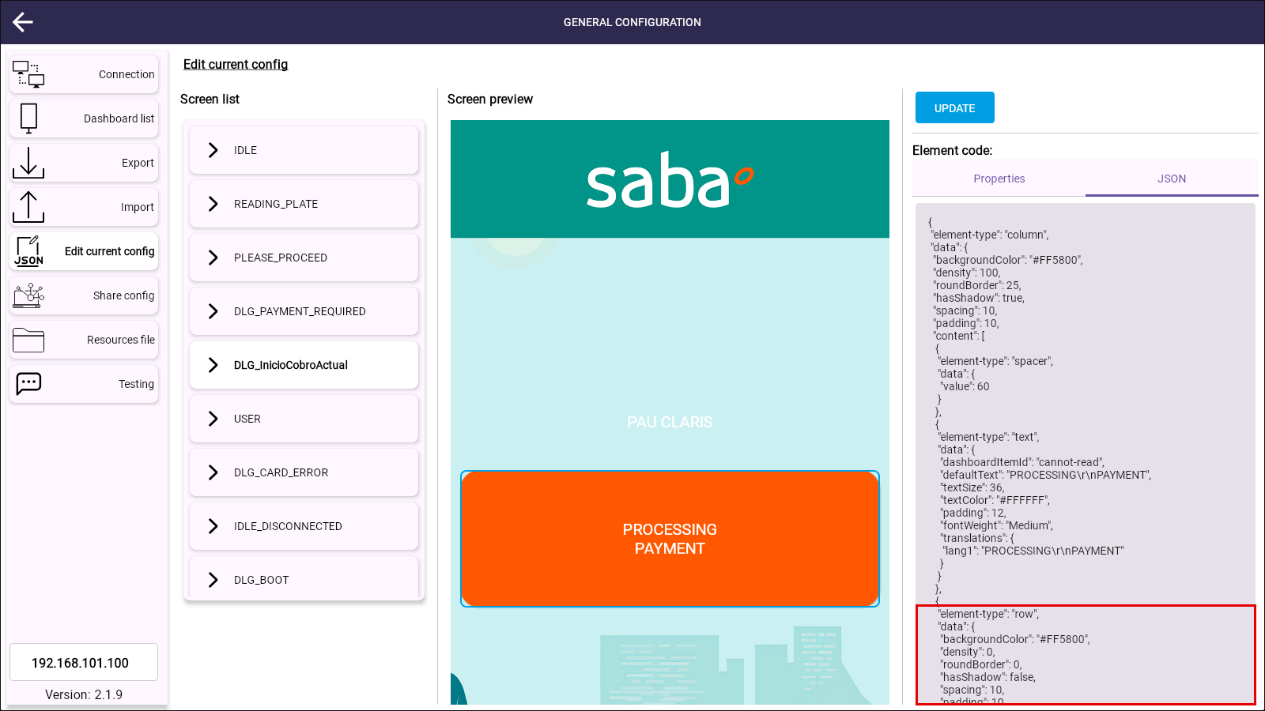
Figure 17. Code of the column with the Amount to pay row pasted.
- Scroll to the end of the code and click APPLY CHANGES. The screen preview shows the Amount to pay message again.
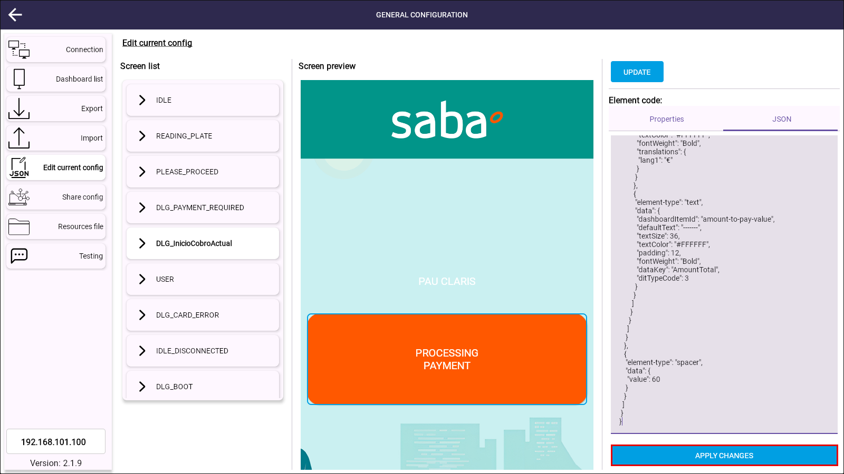
Figure 18. APPLY CHANGES at the end of the JSON tab.
Note: If the code is not a valid JSON element, the editor shows the message "The element code is not a valid JSON element" in red and APPLY CHANGES is disabled.
- Click UPDATE and then ACCEPT in the confirmation message.
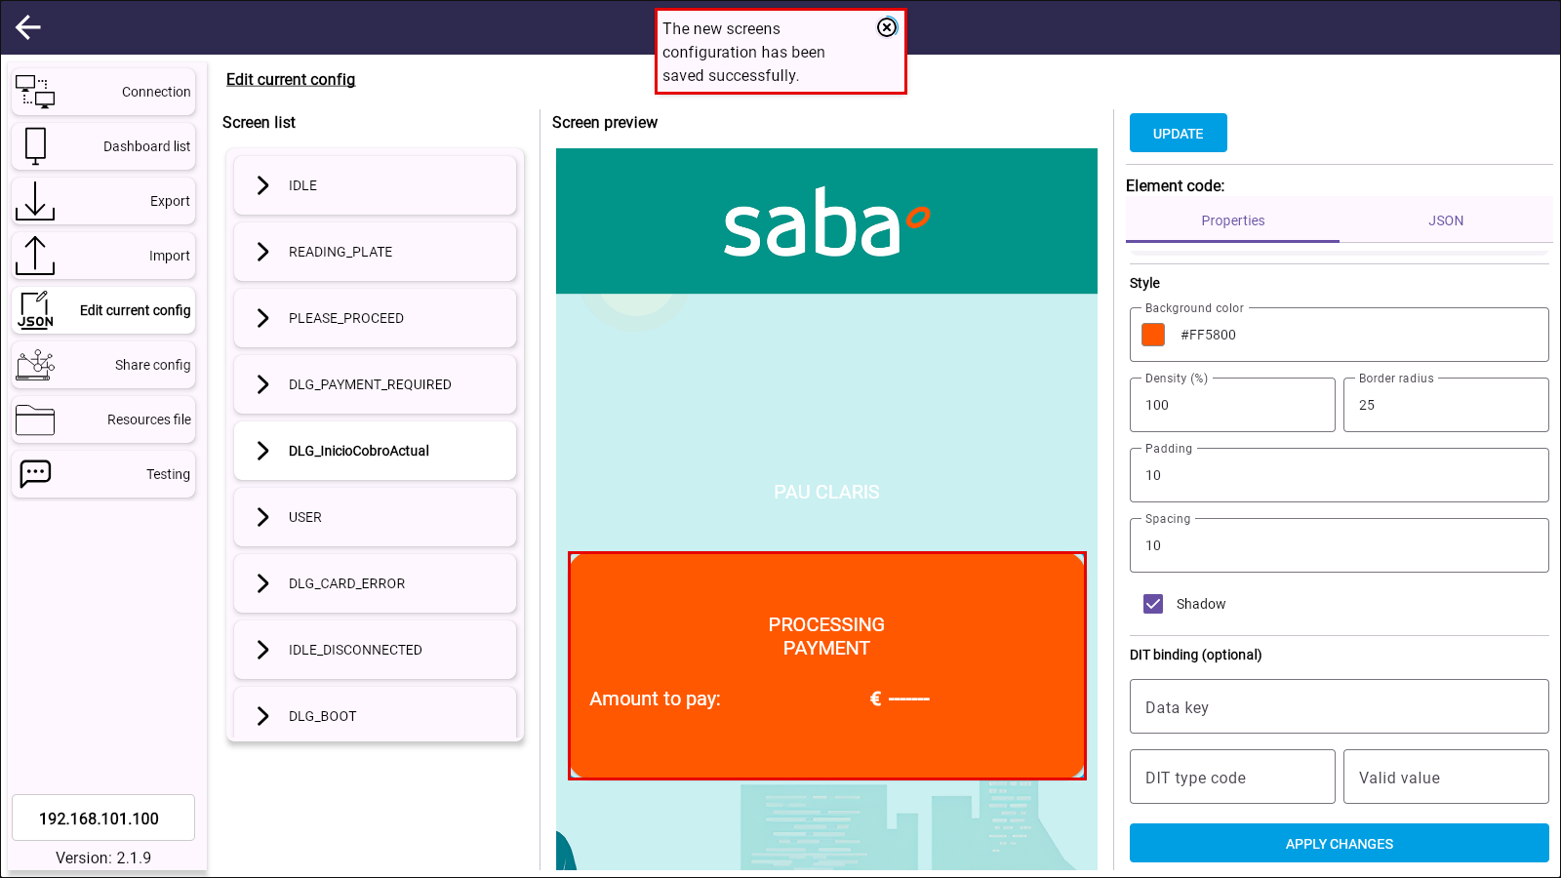
Figure 19. Configuration saved on the display with the Amount to pay row restored.
When the tab is opened again, the element read from the display shows the row in the Structure tree:
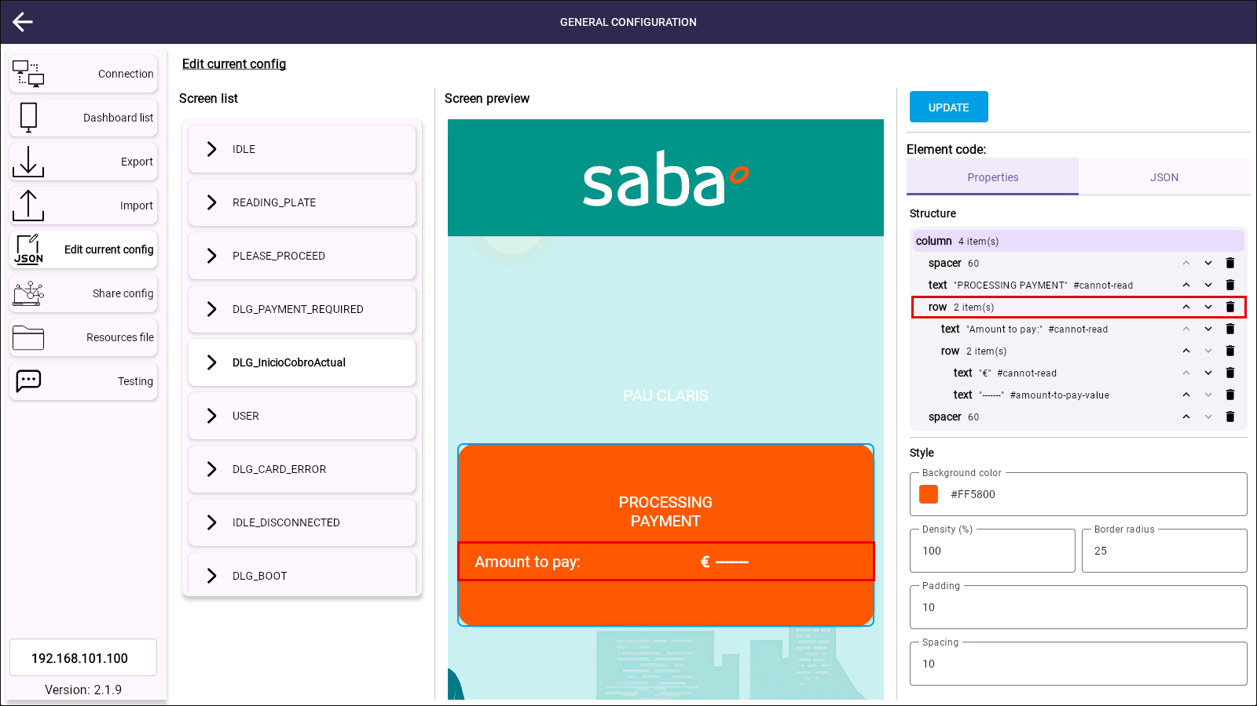
Figure 20. Structure read from the display after the update. The Amount to pay row is present.
- Select the Testing tab and select DLG_InicioCobroActual. The Amount To Pay (Type 3) DIT form is shown again.
- Type 875 in AmountTotal and 0 in AmountAlreadyPayed, and click SEND.
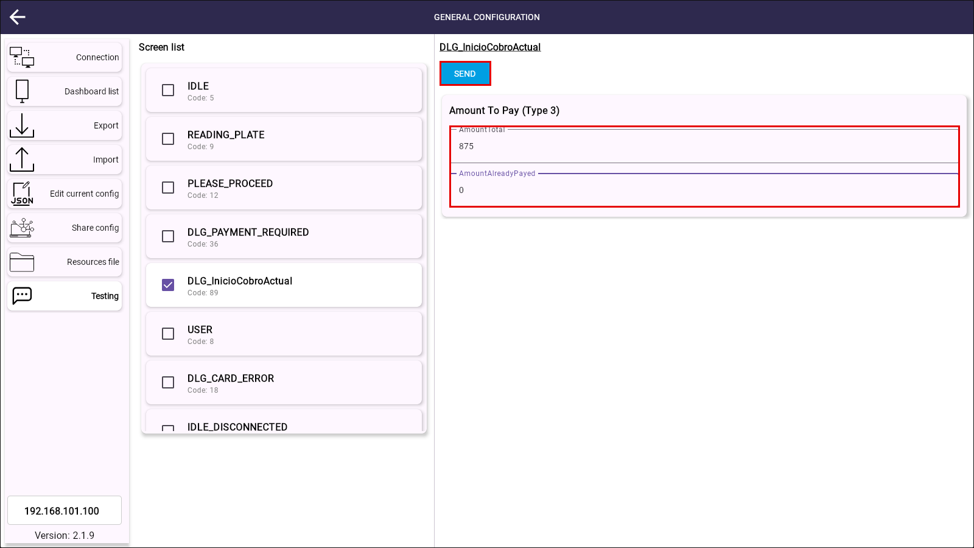
Figure 21. Testing tab with the DIT of the amount to pay.
Expected result: the display shows PROCESSING PAYMENT and "Amount to pay: € 8.75".
Result: PASSED. The message is shown again with the amount received in the DIT. The configuration of the display is the same as before the tests.
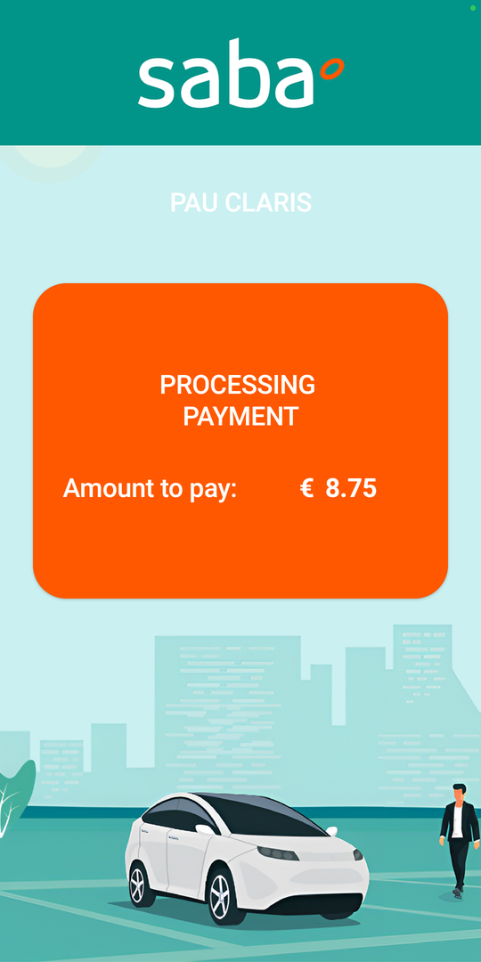
Figure 22. TC-03. The Amount to pay message is shown again.

Conclusion
The three tests passed. The Amount to pay message of the DLG_InicioCobroActual screen is enabled or disabled from the Edit current config tab of the web configurator, and the display shows the change as soon as the screen is received:
Figure 23. Message enabled (TC-01). | Figure 24. Message disabled (TC-02).

- To disable the message, remove the Amount to pay row with the bin icon of the Properties tab and click UPDATE.
- To enable it again, add the code of the row in the JSON tab (section 7) and click UPDATE.
- When the message is disabled, the screen does not need the Amount To Pay DIT (type 3).

Annex. Code of the Amount to pay row
Code of the row used in TC-03. It must be the third element of the content list of the orange column of DLG_InicioCobroActual:
{
"element-type": "row",
"data": {
"backgroundColor": "#FF5800",
"density": 0,
"roundBorder": 0,
"hasShadow": false,
"spacing": 10,
"padding": 10,
"content": [
{
"element-type": "text",
"data": {
"dashboardItemId": "cannot-read",
"defaultText": "Amount to pay:",
"textSize": 36,
"textColor": "#FFFFFF",
"padding": 12,
"fontWeight": "Medium",
"translations": {
"lang1": "Amount to pay:"
}
}
},
{
"element-type": "row",
"data": {
"backgroundColor": "#FF5800",
"density": 0,
"roundBorder": 0,
"hasShadow": false,
"spacing": 0,
"content": [
{
"element-type": "text",
"data": {
"dashboardItemId": "cannot-read",
"defaultText": "€",
"textSize": 36,
"textColor": "#FFFFFF",
"fontWeight": "Bold",
"translations": {
"lang1": "€"
}
}
},
{
"element-type": "text",
"data": {
"dashboardItemId": "amount-to-pay-value",
"defaultText": "-------",
"textSize": 36,
"textColor": "#FFFFFF",
"padding": 12,
"fontWeight": "Bold",
"dataKey": "AmountTotal",
"ditTypeCode": 3
}
}
]
}
}
]
}
}

